**SMART TRAFFIC LIGHT**

**CONTROL SYSTEM**

**PBL REPORT**

**In**

**Embedded Systems**

**Submitted as a Course Project**

***by***

**Jagmohan Singh (13BCE1056)**

**Marla Akhil Reddy (13BCE1078)**

**Under the Guidance**

**Prof.Sridhar Ranganathan**

**Associate Professor**

**School of Computing Science and Engineering**



**VIT University**

**Chennai- 600 127 – INDIA**

**May 2016**

**CONTENTS**

|  |  |
| --- | --- |
| **ABSTRACT** | **3** |
| **Design/Algorithum** | **4** |
| **Block Diagram** | **7** |
| **Software/ Tools used** | **8** |
| **Cost Estimation** | **9** |
| **Work Done** | **15** |
| **Use Cases** | **17** |
| **Coding** | **22** |
| **Working Model Diagram** | **39** |
| **Working Constraints** | **60** |
| **Future Scope of Project** | **61** |
| **Referances** | **62** |

Abstract

Traffic signals are the most convenient method of controlling traffic in a busy junction. But, we can see that these signals fail to control the traffic effectively when a particular lane has got more traffic than the other lanes. This situation makes that particular lane more crowdie than the other lanes. If the traffic signals can allot different lanes to different vehicles based on their weight, like buses, trucks etc. in one lane, cars in one lane and like this the traffic congestion can be solved by diverging the traffic accordingly. In this method, intend to measure the traffic density by counting the number of vehicles in each lane and their weight, then park in automated parking or diverge them accordingly. It is also difficult for a traffic police to monitor the whole scenario round the clock. So, this system can be implemented on highways and city traffic.

Considering the heavy traffic congestion on daily basis sometimes emergency vehicles like ambulance get struck in the congestion which complicates the situation. Normal traffic lights are not able to operate according to the requirement of the emergency vehicles. So, our project basically aims to make them operate keeping the track of the emergency situation.

**Design/Algorithm**

We are basically operating the traffic light based on the interrupt given by the emergency vehicle .So when it gets the interrupt from the ambulance it turns off all the traffic signal apart from one on which the ambulance is coming.

**Proposed-** In the project ir transmitter is being used which will transmit the code and the receiver will detect it then microcontroller(Arduino) will get an interrupt and it will stop the normal functioning of the traffic signal and free the path of the ambulance by making the light green.

**CCN components to be applied-**

Source encoding and Decoding and error detection like checksum and parity Checker.

**Design Schematic/Flow Diagram/Block Diagram**

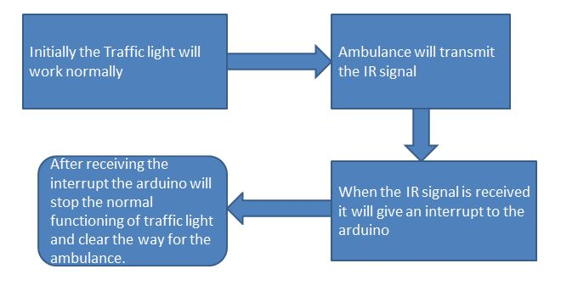

**Components Used (S/w, H/w)**

**Hardware components:**

* **IR module**
* **Arduino**
* **Breadboard**
* **lEDs, Resistors**
* **Jumper and connecting wires**

**Software Used:**

* **Arduino(IDE)**

**Cost Estimation:**

**Around 250 if we use a general micro controller instead of Arduino.**

**Work Done**

**Whenever there is no emergency vehicle like ambulance, the traffic system will work as usual but when vehicle comes it will turn on the green light (according to program) so ambulance will not have to wait.**

**For making it full proof, source encoding and error detection is done by assigning a specific code to ambulance.**

**USE CASES**

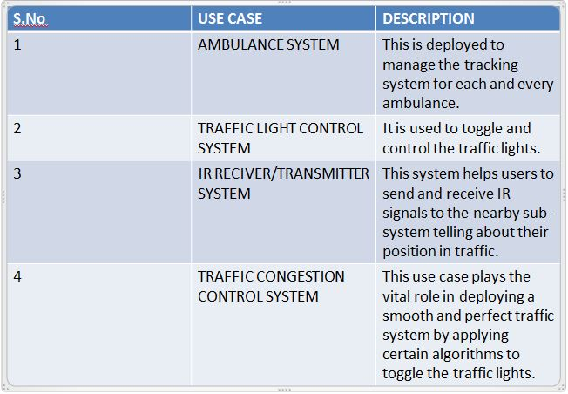

Code for the Project

Working Model Diagram

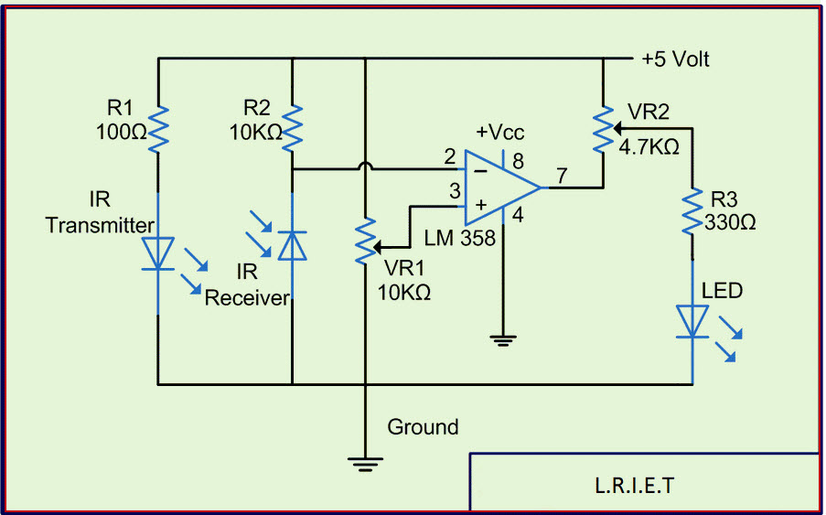

Working Constraints

* Traffic congestion needs to happen for deploying this technique.
* Only aiming at VIP/Ambulance vehicles.
* Works using IR so restricted to particular radius.
* Only applicable to Tier-1 city with traffic lights already installed.

**Future Scope of Project**

* In future this project can be implemented to each and every vehicle irrespective of the priority.
* IR can be replaced by GPS modules to increase the effectiveness and span of the connection.
* It can be use as a tracking device by the company to seek their employees current positions, like pizza delivery or e-kart suppliers etc.
* By using the tracking sensor we can implement our own traffic cloud system to help user to navigate through less clumsy path.

**Reference Papers/Web Links**

<https://www.elprocus.com/infrared-ir-sensor-circuit-and-working/>

[www.google.com](http://www.google.com/)